SOLAR B-LITE
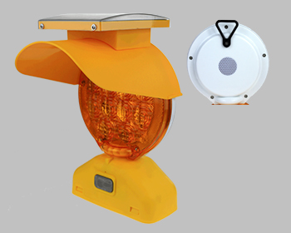
Our Solar B-Lite has been a leading Warning Light Solution for many years. A revised solar panel mold has reduced our material cost allowing us to pass the savings on to our customers making it one of the lowest cost, fully solar lights on the market. The high quality and maintenance free operation our customers expect remains. The upgraded Lithium Ion battery pack provides years of service

- Fully compliant with MUTCD Specification 6E5
- Fully compliant with ITE Specifications
- State of the art photovoltaic technology
- High throughput technology allows maximum intensity
- Maintenance free operation eliminates service expenses
- Weatherproof design ensures operation in all climates and conditions
- Produced under the strictest quality Standards
- 2 year limited warranty

www.interplexsolar.com

